

Proposal template: technical annex
Research and Innovation actions
Call: H2020-FETOPEN-2018-2020
Topic: FETOPEN-01-2018-2019-2020: FET-Open Challenging Current Thinking

The structure of this template must be followed when preparing your proposal. It has been designed to ensure that the important aspects of your planned work are presented in a way that will enable the experts to make an effective assessment against the evaluation criteria. Sections 1, 2 and 3 each correspond to an evaluation criterion.
Please be aware that proposals will be evaluated as they were submitted, rather than on their potential if certain changes were to be made. This means that only proposals that successfully address all the required aspects will have a chance of being funded. There will be no possibility for significant changes to content, budget and consortium composition during grant preparation.
A proposal that, according to the evaluators' assessments, does not convincingly satisfy all FET gatekeepers as described in the FET Work Programme will be declared out of scope.

Page limit: Sections 1 to 3 of the proposal should consist of a maximum of 15 A4 pages (no cover page). All tables, figures, references and any other element pertaining to these sections must be included as an integral part of these sections and are thus counted against this page limit. There is no page limit for sections 4 and 5.
The page limit will be applied automatically; therefore you must remove the first 2 instruction pages of this template before submitting.
If you attempt to upload a proposal longer than the specified limit before the deadline, you will receive an automatic warning and will be advised to shorten and re-upload the proposal. After the deadline, excess pages (in over-long proposals/applications) will be automatically made invisible, and will not be taken into consideration by the experts. The proposal is a self-contained document. Experts will be instructed to ignore hyperlinks to information that is specifically designed to expand the proposal, thus circumventing the page limit.

The following formatting conditions apply.
Each page should include a footnote with the acronym of the proposal.
The reference font for the body text of H2020 proposals is Times New Roman (Windows platforms), Times/Times New Roman (Apple platforms) or Nimbus Roman No. 9 L (Linux distributions).
The use of a different font for the body text is not advised and is subject to the cumulative conditions that the font is legible and that its use does not significantly shorten the representation of the proposal in number of pages compared to using the reference font (for example with a view to bypass the page limit).
The minimum font size allowed is 11 points. Standard character spacing and a minimum of single line spacing is to be used.
Text elements other than the body text, such as headers, foot/end notes, captions, formula's, may deviate, but must be legible.
The page size is A4, and all margins (top, bottom, left, right) should be at least 15 mm (not including any footers or headers).

PROPOSAL TITLE
Multiledger Automated Research Network
OR
Deep Multiledger Automated Network
Acronyms: ROBHOOT or DEMANext.. others?
1. Excellence
  - Radical vision of a science-enabled technology
Distributed ledger technologies are disrupting many sectors nowadays impacting knowledge-inspired societies and governance. Many existing open decentralized networks focusing on specific layers in science and engineering are already providing solutions to improve open and reproducible science (i.e., sensor networks, data processing, inference, visualization, publishing, etc.) However, science and engineering process require the integration of many layers to facilitate reproducibility, cooperation, new science of science methodologies, and public access to the full research cycle and research findings. Yet, technologies to compactly facilitate, reproduce and distribute the events within and among layers, an open multiledger automated network technology is currently not in place. Our research proposal aims to deploy a multiledger automated network accounting fully for the research cycle to provide decentralized and real-time open-access data-rule-knowledge to gain informed decisions to help solve complex social and technological problems.

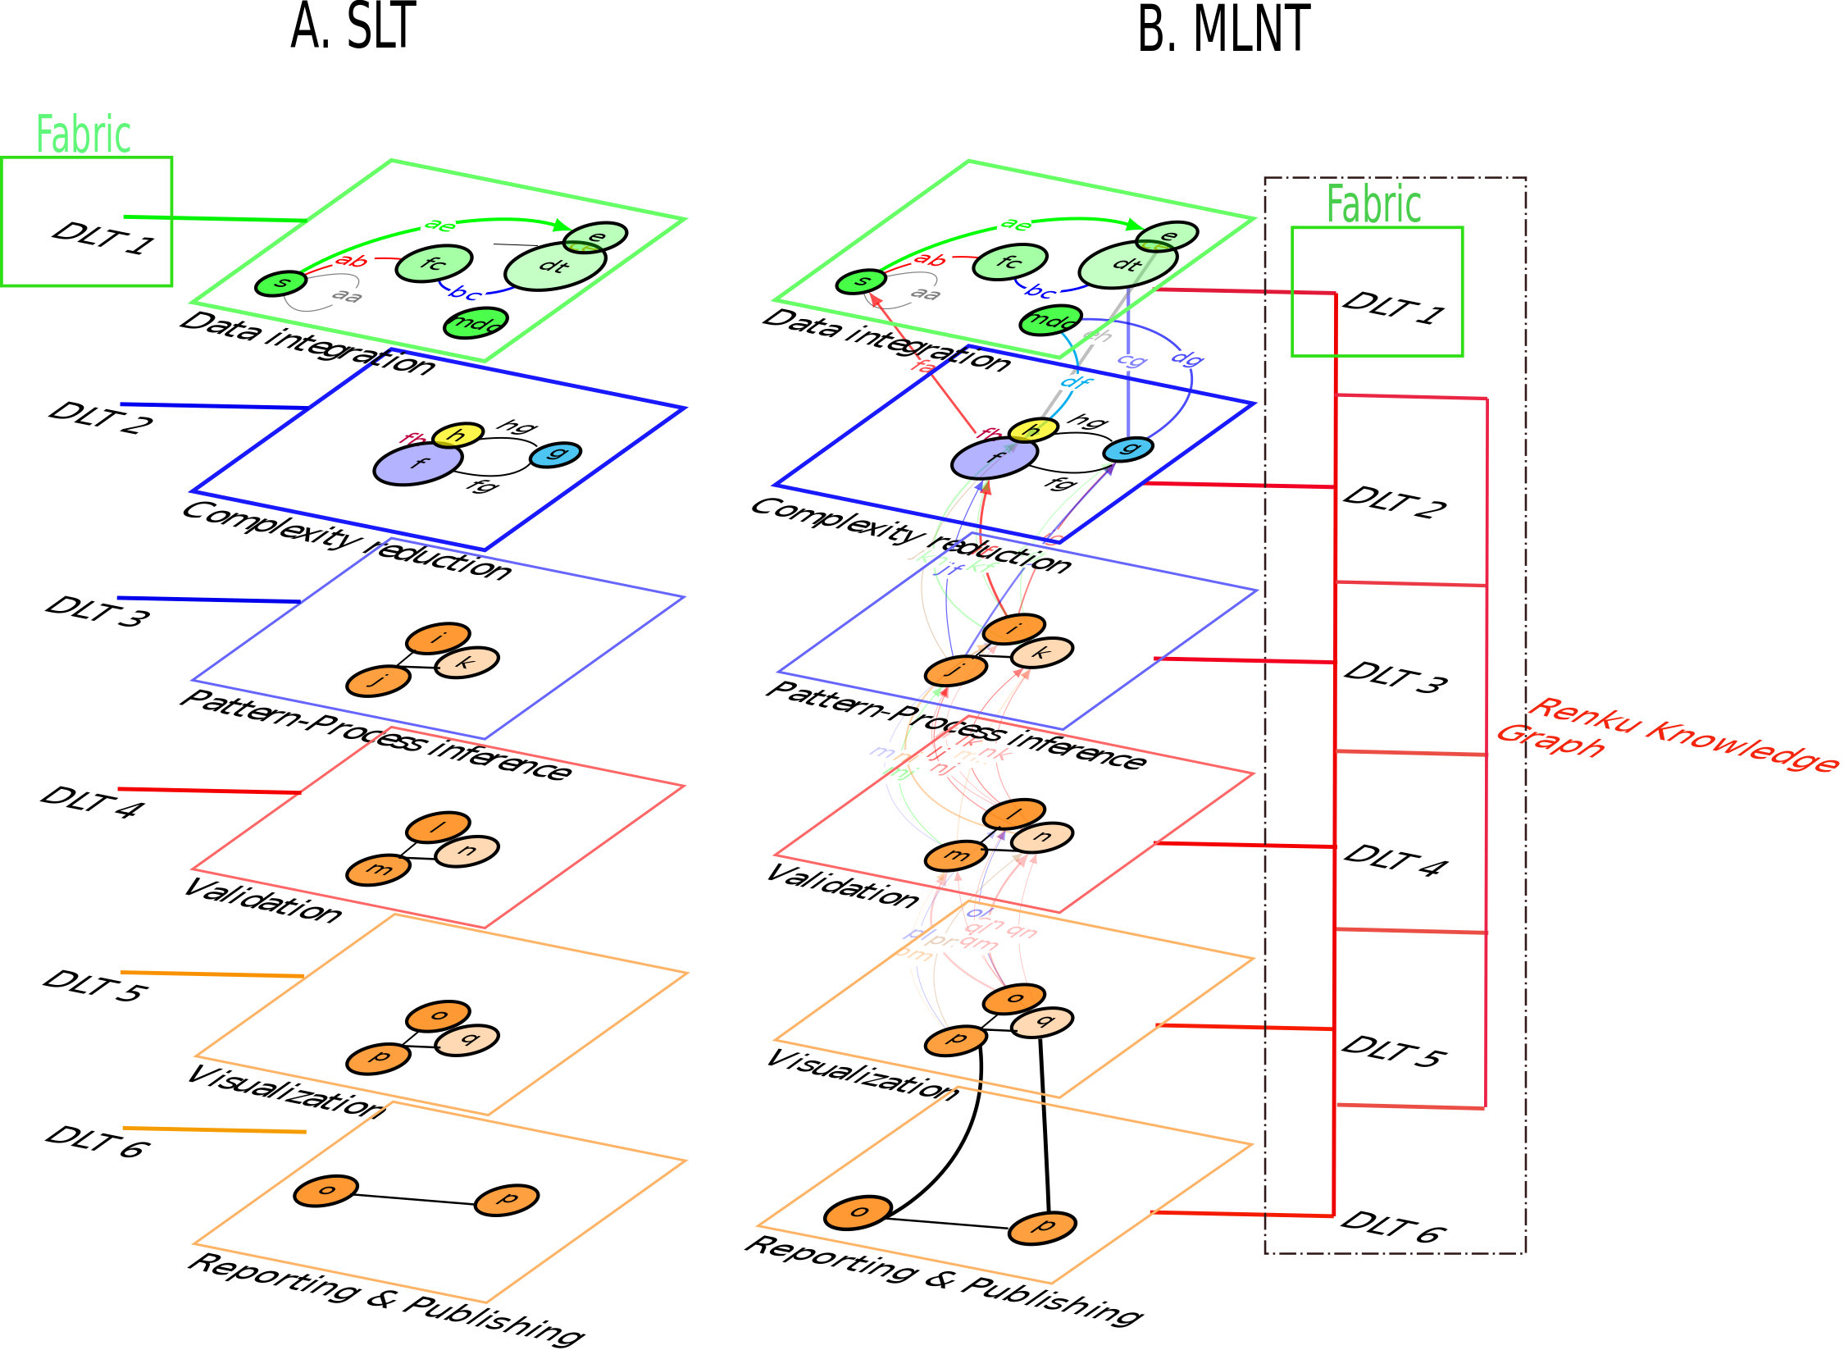
Figure 1: A) Simple Ledger Technology (SLT) accounting for each stage of the research cycle (For example, data integration, complexity reduction, pattern-process inference, validation, visualization and reporting and publishing). SLT allows recording transactions maintained within a distributed network of mutually untrusting peers with every peer maintaining a copy of the ledger. B) Multi-Ledger Network Technology (MLNT) aims to syncrhonize the transactions maintained within and between distributed networks with the Renku Knowledge Graph. Each full research cycle is now maintained and distributed in a open multiledger network.

Main overall objectives of the project:
1. Deploy a multiledger automated network technology intergrating distributed open-source OS for permissioned-permissionless blockchains with a lineage client-tracker of the full research cycle.
2. Deploy a Robhoot Open Network in Biodiversity Research as a case study to facilitate accessibility to open science.
3. Develop an interface to drive the integration between SLT and MLNT with the aim to provide real-time open-access data-rule-knowledge to gain informed decisions to help solve complex social and technological problems.
Each of the overall objectives has specific ones. Briefly describe them here.

  - Science-to-technology breakthrough that addresses this vision
Peer-to-peer interactions abound in natural and social ecosystems compossed both by trusting and untrusting peers. Many studies of natural (refs), technological (refs) and social (refs) systems considering different temporal and spatial scales have produced an immense gain in detailed knowledge at each of the levels and scales studied. More recently, the feedbacks occurring among levels and scales in these systems have provided new unexpected behaviors that are difficult to anticipate when exploring one scale-level alone (refs). Specifically, in biological systems, the genetic arquitecture of functionally important traits might feedback throughout the genotype-phenotype map producing variation in phenotypes that are functionally important to understand the evolution of genotypic and phenotypic variation like the variation in the immune system or resilience to disturbances in natural populations. The main fact in these discoveries is that it is not one level or scale, but a number of them that interact and feedback to each other producing a dynamics that strongly differ from the one-level one-scale approach. Accounting for levels and scales using multilayer networks have provided a framework to explore how the microdynamics of peer-to-peer interactions might connect to the macroscopic properties of the ecosystem like the centralization and the sensitivity to attacks within and between layers and/or levels and scales.
(Science to technology breakthrough) Technological systems still lack a framework to deploy multilayer networks: multiledger automated networks. The ecosystem in science and engineering is full of peer-to-peer interactions and platforms to facilitate the scientific and engineering enterprise. Currently, many projects have failed in reproducibility in publicly-funded science and technology (refs). Yet, despite public institutions are demanding more reproducibility and openness of the data (refs), and overall a shifting of towards open and reproducible scientific and engineering landscapes, there are not technologies aiming to compactly facilitate, reproduce and distribute the events within and among layers of the scientific and engineering enterprise to provide decentralized and real-time open-access data-rule-knowledge to gain informed decisions to help solve complex social and technological problems.
Multiledger automated networks
SLT development:: Fabric OS, the TON network, the interaction between blockchains or netwotks, main results in multilayer networks: how are they different from unilayer networks? >> Which is the road to MLNT? Which is the connection between Multilayer networks and MLNT? How MLNT will move the field beyond the state-of-the-art?
  - Interdisciplinarity and non-incrementality of the research proposed

Interdisciplinarity
Data science, Computer science, Physics of complex Systems, Ecology and Evolution and Biodiversity research
Non-incrementality
Develop a de-novo multiledger automated network:
Integrating is incremental (merging Fabric and Renku)
Where is the non-incrementality? Explain

  - High risk, plausibility and flexibility of the research approach
Briefly outline how to deal with the uncertainty? Security, Scalability and Adoption :: Working case study in Biodiversity research to facilitate adoption of the RON
2. Impact
2.1 Expected impacts

2.2 Measures to maximise impact
a) Dissemination and exploitation of results

b) Communication activities

3. Implementation
  - Research methodology and work plan – Work packages, deliverables
Please provide the following:
- details of the research methodology and overall structure of the work plan;
- timing of the different work packages and their components (Gantt chart or similar);
- Please use the following indicative table for the project reporting periods (Rps):

Proposed length of the project (months) | RP1 duration (months) | RP2 duration (months) | RP3 duration (months)
48 | 12 | 18 | 18
42 | 12 | 12 | 18
36 | 12 | 24
30 | 12 | 18
24 | 12 | 12

- detailed work description, i.e.:
  - a list of work packages (table 3.1a);
  - a description of each work package (table 3.1b);
  - a list of all deliverables (table 3.1c);
- Graphical presentation of the work packages showing how they inter-relate (Pert chart or similar).
Give full details. Base your account on the logical structure of the project and the stages in which it is to be carried out. The number of work packages should be proportionate to the scale and complexity of the project.
You should give enough detail in each work package to justify the proposed resources to be allocated and also quantified information so that progress can be monitored, including by the Agency
Resources assigned to work packages should be in line with their objectives and deliverables. You are advised to include a distinct work package on ‘management’ (see section 3.2) and to give due visibility in the work plan to ‘dissemination and exploitation’ and ‘communication activities’, either with distinct tasks or distinct work packages.
You will be required to include an updated (or confirmed) ‘plan for the dissemination and exploitation of results’ in both the periodic and final reports. This should include a record of activities related to dissemination and exploitation that have been undertaken and those still planned. A report of completed and planned communication activities will also be required.
If your project is taking part in the Pilot on Open Research Data, you must include a 'data management plan' as a distinct deliverable within the first 6 months of the project. A template for such a plan is given in the guidelines on data management in the H2020 Online Manual. This deliverable will evolve during the lifetime of the project in order to present the status of the project's reflections on data management.
Definitions:
‘Work package’ means a major sub-division of the proposed project.
‘Deliverable’ means a distinct output of the project, meaningful in terms of the project's overall objectives and constituted by a report, a document, a technical diagram, a software etc.
- Management structure, milestones and procedures
- Describe the organisational structure and the decision-making (including a list of milestones (table 3.2a))
- Explain why the organisational structure and decision-making mechanisms are appropriate to the complexity and scale of the project.
  - Describe any critical risks, relating to project implementation, that the stated project's objectives may not be achieved. Detail any risk mitigation measures. Please provide a table with critical risks identified and mitigating actions (table 3.2b) and relate these to the milestones.
Definition:
‘Milestones’ means control points in the project that help to chart progress. Milestones may correspond to the completion of a key deliverable, allowing the next phase of the work to begin. They may also be needed at intermediary points so that, if problems have arisen, corrective measures can be taken. A milestone may be a critical decision point in the project where, for example, the consortium must decide which of several technologies to adopt for further development.
  - Consortium as a whole
The individual members of the consortium are described in a separate section 4. There is no need to repeat that information here.
- Describe the consortium. Explain how it will support achieving the project objectives. Does the consortium provide all the necessary expertise? Is the interdisciplinarity in the breakthrough idea reflected in the expertise of the consortium?
- In what way does each of the partners contribute to the project? Show that each has a valid role and adequate resources in the project to fulfil that role. How do the members complement one another?
Other countries and international organisations: If one or more of the participants requesting EU funding is based in a country or is an international organisation that is not automatically eligible for such funding (entities from Member States of the EU, from Associated Countries and from one of the countries in the exhaustive list included in General Annex A of the work programme are automatically eligible for EU funding), explain why the participation of the entity in question is considered essential for carrying out the action on the grounds that participation by the applicant has clear benefits for the consortium.
  - Resources to be committed
- Please make sure the information in this section matches the costs as stated in the budget table in section 3 of the administrative proposal forms, and the number of person months, shown in the detailed work package descriptions.
Please provide the following:
- a table showing number of person months required (table 3.4a)
- a table showing ‘other direct costs’ (table 3.4b) for participants where those costs exceed 15% of the personnel costs (according to the budget table in section 3 of the administrative proposal forms)

Tables for section 3.1
Table 3.1a: List of work packages

Work package No | Work Package Title | Lead Participant No | Lead Participant Short Name | Person-Months | Start Month | End month
 |  |  |  | Total person- months

Table 3.1b: Work package description
For each work package:

Work package number |  |  |  | Lead beneficiary
Work package title
Participant number
Short name of participant
Person months per participant:
Start month |  |  |  |  |  |  | End month

Objectives

Description of work (where appropriate, broken down into tasks and deliverables), lead partner and role of participants.

Deliverables (brief description and month of delivery)

Table 3.1c: List of Deliverables

Deliverable (number) | Deliverable name | Work package number | Short name of lead participant | Type | Dissemination level | Delivery date  (in months)

KEY
Deliverable numbers in order of delivery dates. Please use the numbering convention <WP number>.<number of deliverable within that WP>.

For example, deliverable 4.2 would be the second deliverable from work package 4.

Type:
Use one of the following codes:
R: Document, report (excluding the periodic and final reports)
DEM: Demonstrator, pilot, prototype, plan designs
DEC: Websites, patents filing, press & media actions, videos, etc.
OTHER: Software, technical diagram, etc.

Dissemination level:
Use one of the following codes:
PU = Public, fully open, e.g. web
CO = Confidential, restricted under conditions set out in Model Grant Agreement
CI = Classified, information as referred to in Commission Decision 2001/844/EC.

Delivery date
Measured in months from the project start date (month 1)

Tables for section 3.2
Table 3.2a: List of milestones
Milestone number | Milestone name | Related work package(s) | Due date (in month) | Means of verification

KEY
Due date
Measured in months from the project start date (month 1)

Means of verification
Show how you will confirm that the milestone has been attained. Refer to indicators if appropriate. For example: a laboratory prototype that is ‘up and running’; software released and validated by a user group; field survey complete and data quality validated.

Table 3.2b: Critical risks for implementation
Description of risk (indicate level of likelihood: Low/Medium/High) | Work package(s) involved | Proposed risk-mitigation measures

Definition critical risk:
A critical risk is a plausible event or issue that could have a high adverse impact on the ability of the project to achieve its objectives.

Level of likelihood to occur: Low/medium/high
The likelihood is the estimated probability that the risk will materialise even after taking account of the mitigating measures put in place.

Tables for section 3.4
Table 3.4a: Summary of staff effort
Please indicate the number of person/months over the whole duration of the planned work, for each work package, for each participant. Identify the work-package leader for each WP by showing the relevant person-month figure in bold.

 | WP1 | WP2 | WPn | Total Person-  Months per Participant
Participant Number/Short Name
Participant Number/
Short Name
Participant Number/
Short Name
Total Person Months per WP |  |  |  | Total Person Months

Table 3.4b: ‘Other direct cost’ items (travel, equipment, other goods and services, large research infrastructure)

Please complete the table below for each participant when the sum of the costs for Travel, Equipment, and Other goods and services exceeds 15% of the personnel costs for that participant (according to the budget table in section 3 of the proposal administrative forms).
Participant Number/Short Name | Cost (€) | Justification
Travel
Equipment
Other goods and services
Total

Please complete the table below for all participants that would like to declare costs of large research infrastructure under Article 6.2 of the General Model Agreement, irrespective of the percentage of personnel costs. Please indicate (in the justification) if the beneficiary’s methodology for declaring the costs for large research infrastructure has already been positively assessed by the Commission.
Participant Number/Short Name | Cost (€) | Justification
Large research infrastructure

If your action is taking part in the Pilot on Open Research Data, you must include a data management plan as a distinct deliverable within the first 6 months of the project. This deliverable will evolve during the lifetime of the project in order to present the status of the project's reflections on data management. A template for such a plan is available in the H2020 Online Manual on the Participant Portal.
Large research infrastructure means research infrastructure of a total value of at least EUR 20 million, for a beneficiary. More information and further guidance on the direct costing for the large research infrastructure is available in the H2020 Online Manual on the Participant Portal.

